Greg and Tim,

I have attached a Word document with the draft forecast write-up and figures and an Excel file (Report.xlsx) with all the ADMB numerical output. I have also attached an Excel version of the model so you can relate the format of past models with the format of the ADMB report. Please review the documents and share any edits, suggestions, or concerns and I will make changes.

I reached the end of the modeling and didn’t feel like the model with the aerial survey weightings that we decided upon fit the aerial surveys the way you have described them to me. If I understand correctly, the best aerial survey estimates that we have (those we ranked 0.5 – 0.8) represent the closest we have to unbiased estimates. The others (those we ranked 0.1 - 0.25) are ones that we expect are biased low due to weather, limited numbers of surveys, or timing of surveys, but should serve as a minimum biomass in those respective years. When I ran the model with our weightings, the model-estimated biomass falls below nearly all of the best aerial survey estimates (see the first graph below, the size of the green dots reflect the weighting). What this says to me is that, by including estimates that are biased low in the model, even if they are weighted low we are biasing our model estimates low. They aren’t really serving as a minimum limit, but are pulling the model estimates lower than our best estimates.

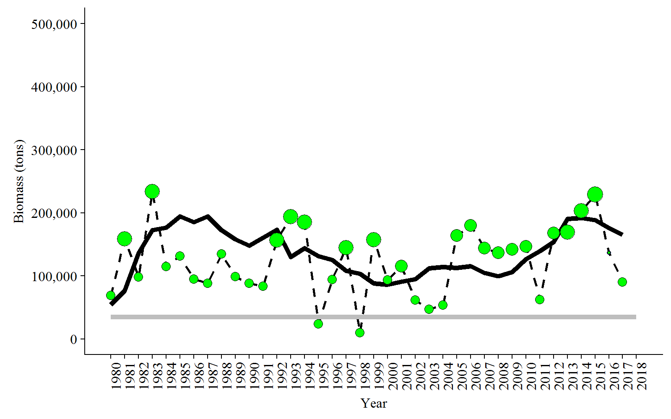

So in the attached write-up I have proposed a slightly different weighting. This is easy to change, so please see what you think and let me know if you have better ideas. I have included all the ranks for our best estimates the same as before (these are the ones that range from 0.5 to 0.8), but have changed the weighting on estimates that were 0.1 or 0.25 to zero. This effectively takes them “out” of the model. However, I have included all of the aerial survey estimates in the graphics. My thought is that by taking them out of the model, we eliminate the known/expected negative bias, but if the model trend ever falls below one of those estimates in the graphs we will know that the model estimate is too low and can do something to fix it. My hope is that they can serve as a minimum that way. The model estimated biomass now fluctuates lower than some of our best aerial estimates and lower than others, which makes more sense to me given your descriptions of the estimates. Please note that this means I weighted both the 2016 and 2017 aerial surveys at zero, so see if that makes sense to you or if you think we should change. As you will see in the write-up, the peak biomass in the 1980’s is close to but a little higher than past model runs. This is because we chose to weight aerial surveys less than the past in the between-dataset weights (we weighted age compositions higher than the aerial surveys in the objective function) and the within-dataset weights of the 1980, 1982, 1991, 1992, and 1993 aerial surveys are now 0.75 compared to 1.0 in the past.

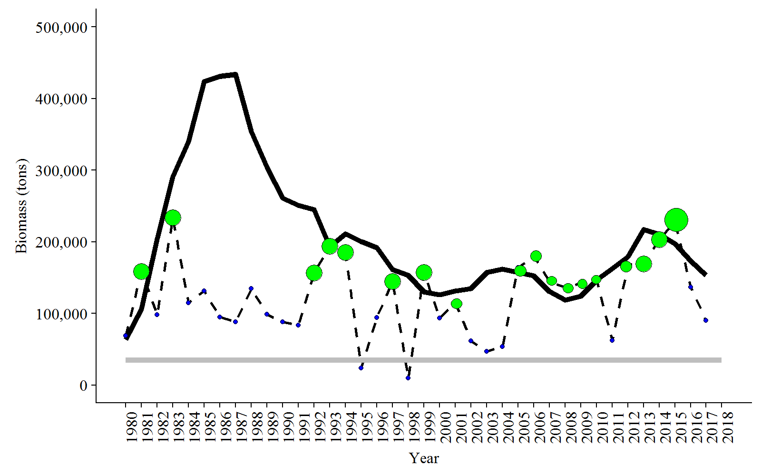

I look forward to hearing your thoughts,

Sherri